- Deploy your your previous assignment flask frontend and express backend in kubernetes cluster locally with minikube.
Create Kind Cluster
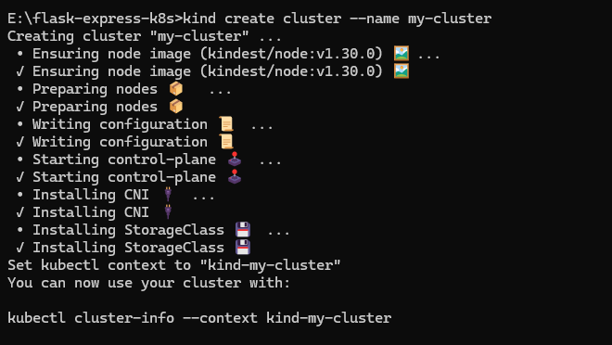
Build Docker image for both frontend and backend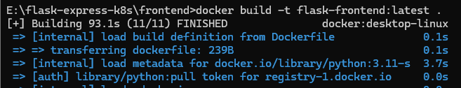
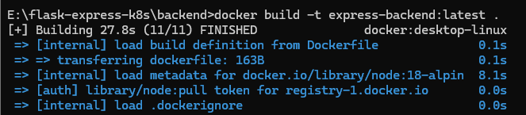

Load image into Kind
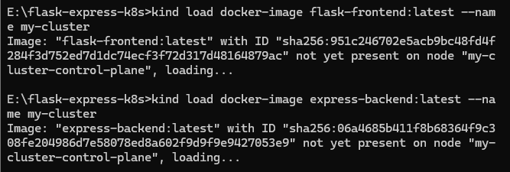
Deploy to kubernetes
